**Cinderella.**

(St.-Valentine’s version of the fairy-tale, adapted from “Poems and plays for children”, Moscow, “Prosvesheniye”, 1977, by Natalia Makarova, school № 324, St-Petersburg.)

**Characters:**

Cinderella

Stepmother

1-st stepsister

2-nd stepsister

Father

Fairy Godmother

Page-boy

King

Queen

1-st Herald

2-nd Herald

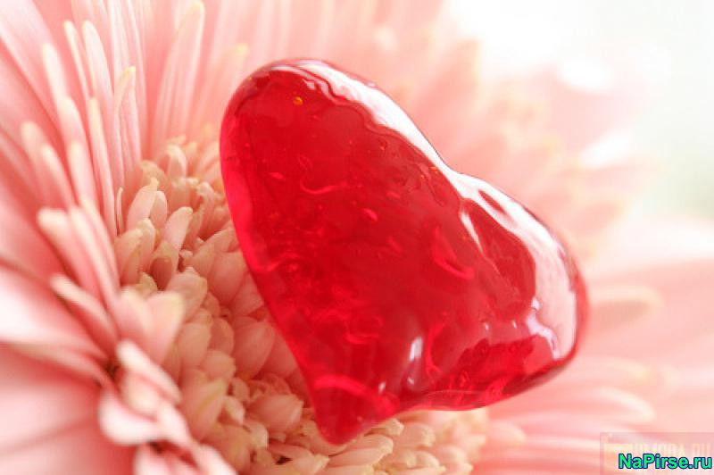

**Scene 1**

*Cinderella is sewing. Her father is repairing the table. Stepsisters are sitting in chairs.*

*Stepmother comes in.*

**Stepmother:** I like parties very much! You know? There will be a St.-Valentine’s party in the Kings palace tomorrow! And we are still not invited. *(To her husband)*Go and ask for an invitation! Immediately!

*(Father goes out and returns in a minute with two heralds)*

**1-st Herald**: Hello ladies!

**2-nd Herald**: There is an invitation to St.-Valentine’s ball in the Kings palace for your family.

**1-st and 2-nd stepsisters**: Great! A St.-Valentine’s party!

**1-st stepsister**: Cinderella! Where is my white dress? I think it is ready?

**Cinderella**: (giving her dress) Here you are!

**2-nd stepsister**: Bring me my hat and the mirror.

*Cinderella brings her the hat and the mirror.*

**Stepmother:** Give my my fan!

*Cinderella gives her the fan*.

**1-st stepsister:** Tell us, Cinderella, do you want to go to the ball?

**Cinderella**: Oh, don’t laugh at me! Nobody will let me in.

**2-nd stepsister**: Of course not! You have no beautiful dress.

**1-st stepsister:** And you have no nice shoes to go there**.**

**Stepmother:** And you are too dirty to go there. OK, we have to go shopping now. Well. Let’s go.

*They leave the room. Cinderella is crying.*

**Father:** My dear child! I would like to help you, but you know- I can’t. Your stepmother hates us!

*Fairy Godmother and her page-boy appear.*

**Fairy Godmother:** Why are you crying my dear child?

**Cinderella:** My dear Fairy. I’m so glad to see you! I cannot go to the party to the King’s palace, because I have neither a beautiful dress, nor glass slippers.

**Fairy Godmother:** My dear! I’ll help you and you will go to the ball! Here is a beautiful dress

**Cinderella:** Thank you very, very much!

**Scene 2**

*At the King’s ball. The King and the Queen enter the room.*

**King:** Dear guests! Welcome to our New Year’s party!

**Queen:** Our dear son!(*To her son***)**Would you like to dance with our guests.

**Prince:** There are so many beautiful ladies here! Of course, I will dance!

*Cinderella appears in a white dress.*

**King:** Who is that young girl? How beautiful she is!

**Prince:** *(approaching Cinderella)* May I dance with you?

**Cinderella:** With great pleasure!

*They begin dancing. (All the guests are dancing too).*

*Suddenly the clock strikes twelve. Everyone starts shouting: “Happy St.Valentine’s day!”*

**Cinderella:** Oh! It’s twelve o’clock! I am sorry, I must go! Good-bye!

*Runs away and loses one of her glass slippers!*

**Prince:** But the holiday has just begun!

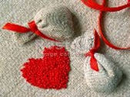

**Scene 3**

*Cinderella is making dinner. The two Stepsisters and Stepmother are talking. Father is cleaning his rifle.*

**1-st Stepsister:** You know, Cinderella, there was a beautiful lady at the party in the King’s palace.

**2-nd Stepsister:** She ran home and lost her glass slipper.

**Stepmother:** And our prince, so cute, so smart boy, wants to marry her. He is looking for her!

*Somebody is knocking the door. Two Heralds and Prince enter the room.*

**1-st Herald:** Dear ladies! Would you be so kind and try, please, this glass slipper*.*

**1-st Stepsister : (** *Trying it on)* It’s too small for me.

**2-nd Stepsister:** Oh! Let me try it on! Oh! It’s too small.

**Stepmother:** I’d like to try it on too! Let me do it!

**2-nd Herald:** Lady! Stop it! May be that girl*(points to Cinderella)* would like to try the glass slipper?

**Prince:** Try it, please!

**Stepmother:** It’s our Cinderella; she hasn’t been to the ball.

**Cinderella**: But I really want to try it on.

*Easily puts on the glass slipper, and takes another one out of her pocket.*

**Prince:** My dear lady, Cinderella! I love you very much! Would you be my Valentine and marry me?

**Cinderella:** My dear Prince! Thank you! With great pleasure!

**Stepsisters:** Oh, Cinderella! We beg your pardon.

**Cinderella:** I pardon you. Good-bye!

*Cinderella and Prince leave the room.*

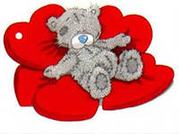

Cinderella.

**A St.-Valentine’s version of the fairy-tale,**

**adapted from**

**“Poems and plays for children”,**

**Moscow, “Prosvesheniye”, 1977**

**by Natalia Makarova, school № 324,**

**Q:\140066.rus\MEDIA\CAGCAT10\j0216516.wmfSt.-Petersburg.**